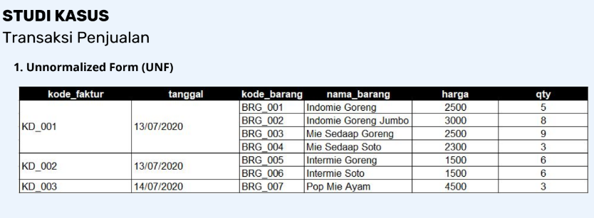

1. **First Normal Form (1NF)**